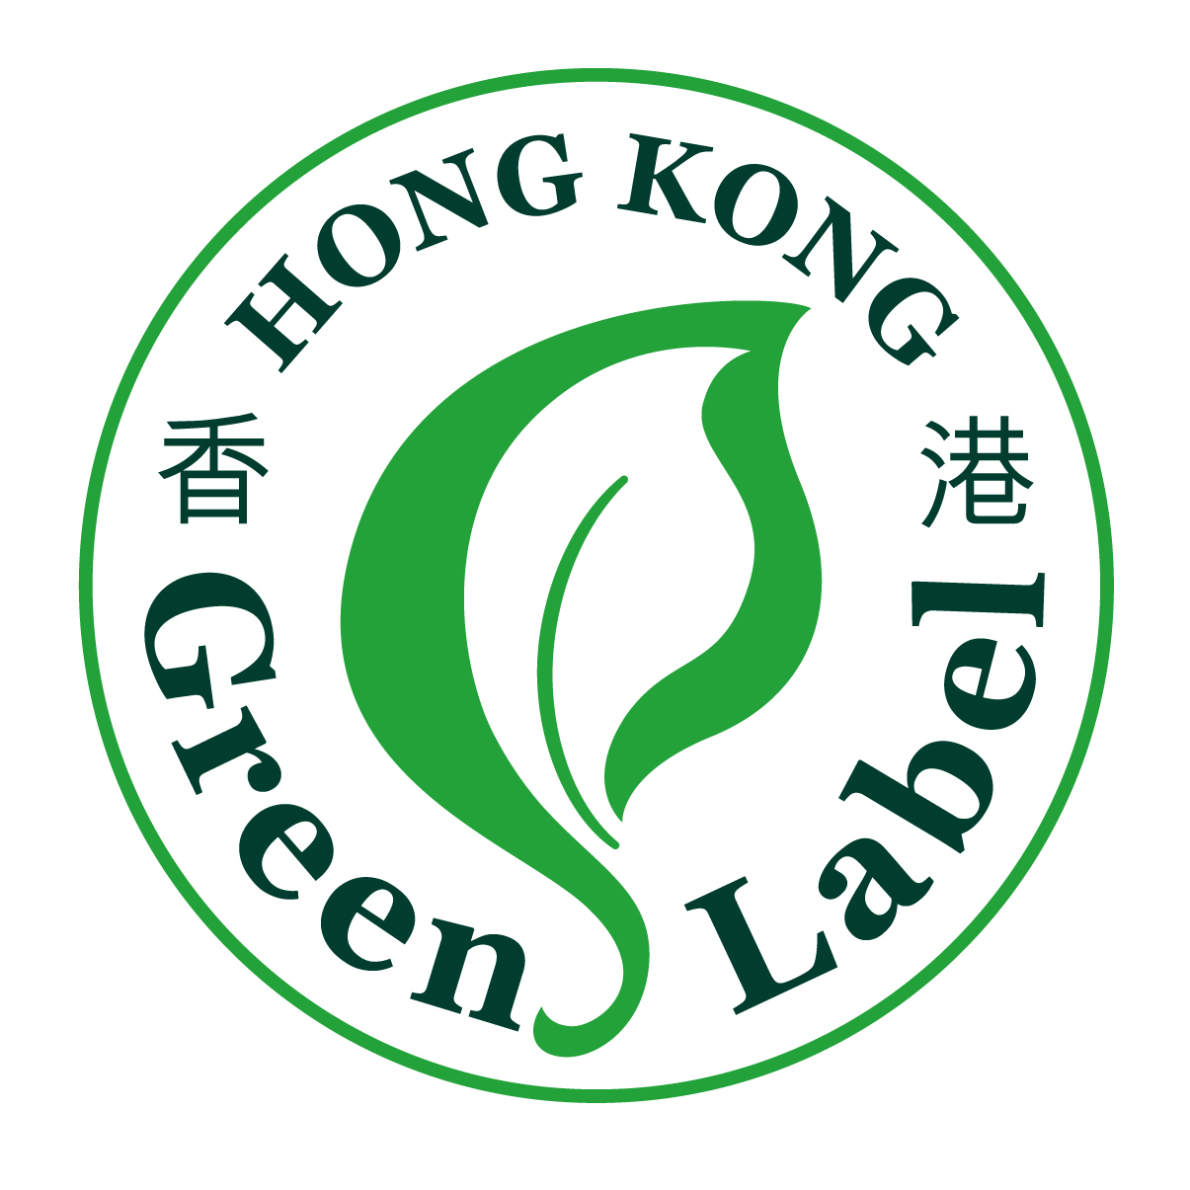
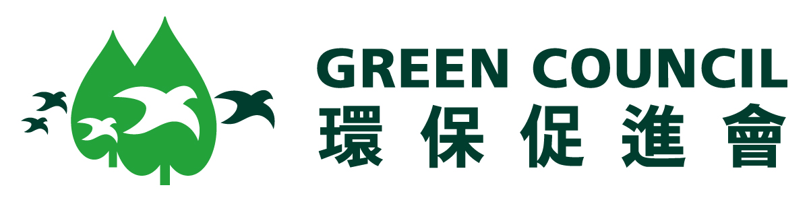

Hong Kong Green Label Scheme
香港環保標籤計劃

Application and Renewal Form
初次申請及續牌申請表格

Please complete the following Application Form and submit it by fax or mail to:
請填妥以下申請表格，然後傳真或郵寄至以下地址：

Green Council 香港中環皇后大道中18號
Rm. 703, New World Tower 1 新世界大廈一期703室
18 Queen’s Road Central 環保促進會
Hong Kong

Tel: (852) 2810 1122 電話: (852) 2810 1122
Fax: (852) 2810 1998 傳真: (852) 2810 1998

Applicant should complete one application form for each product.
申請人需為每項產品個別填寫一份申請表格。

Please ensure that all parts in the form are completed and the information is accurate. If there is insufficient space, please give details on a separate sheet to be attached to the application form.
請填妥申請表內各項資料，並確保資料正確。如位置不足，請以白紙額外填寫補充資料，連同申請表一併遞交。

Please complete or type in black and use block letters  請以黑筆及正楷書寫 |  | For official use  內部專用
1. The Applicant 申請人
First Application初次申請
Renewal Application續牌申請
(HKGLS Certificate No環保標籤証書編號：

Company Name in full公司名稱:

(English)

(中文)
Business Address公司地址:

Hong Kong Applicants only - Business Registration No. (please attach photocopy)
香港申請者適用─商業登記証號碼 (請附上副本):

Overseas Applicants only – please provide evidence of legal status i.e. legally registered co, sole proprietorship or individual.
海外申請者適用─請提供有關法律證明文件，如註冊公司、獨資公司或個人持有者。

Contact Person 聯絡人  (English)  (中文) | Position職位  (English)  (中文)
Tel No.電話號碼:

Fax No.傳真號碼:

Website網址 (if appropriate 如適用者):

E-mail電郵地址:

Nature of Business: (manufacturer, importer, service provider, trader or retailer)
業務性質：(生產商、入口商、供應商、貿易商或零售商)

Environmental claims as appearing on the product and packaging materials
在產品及包裝上聲稱的環保特性:

Any other supporting information (e.g. Certificates of other environmental labelling schemes, environmental management policies or practices, ISO 14000 Certifications, environmental awards etc.)
其他補充資料 (如其他環保標籤計劃証書、環保管理政策或方案、 ISO 14000証書或任何環保獎項等)

2. The Product產品
Product Name產品名稱:  (English)  (中文) |  |  |  |  | For official use  內部專用

Product Brand Name品牌名稱:

(English)

(中文)

Product Model or Internal Reference Number產品型號或序品編號:

Product Description: ( e.g. Characteristics, function and main composition.etc.)

產品資料(如產品特性、功用及主要成份等)

Origin of Product and Manufacturer (e.g. Name, Address, Contact tel no. and fax no.etc. )

產品原產地及生產商資料(如名稱、地址、聯絡電話及傳真號碼等)

Relevant HKGLS Product Category Code

適用的香港環保標籤計劃產品類別編號

When was the product first introduced to the market?
產品何時初次引進市場？

Supporting Documents Required (please attach photocopy)遞交的証明文件(請附上副本):

- Product catalogue and specification
產品目錄及規格書;
- Accredited Laboratory test reports
認可化驗所的化驗報告;
- Certificate(s) of other green labels
其他環保標籤的証書;
- Self-declaration statement; and/or
個人陳述；及/或
- Other relevant certificates and document
其他有關的証書及文件
- Production information e.g. flowchart
生產資料，如生產流程表

Application and Licence Fees申請及牌照費:

I hereby attach to this application a cheque drawn on現隨申請表夾附下述銀行支票: (bank name銀行名稱)
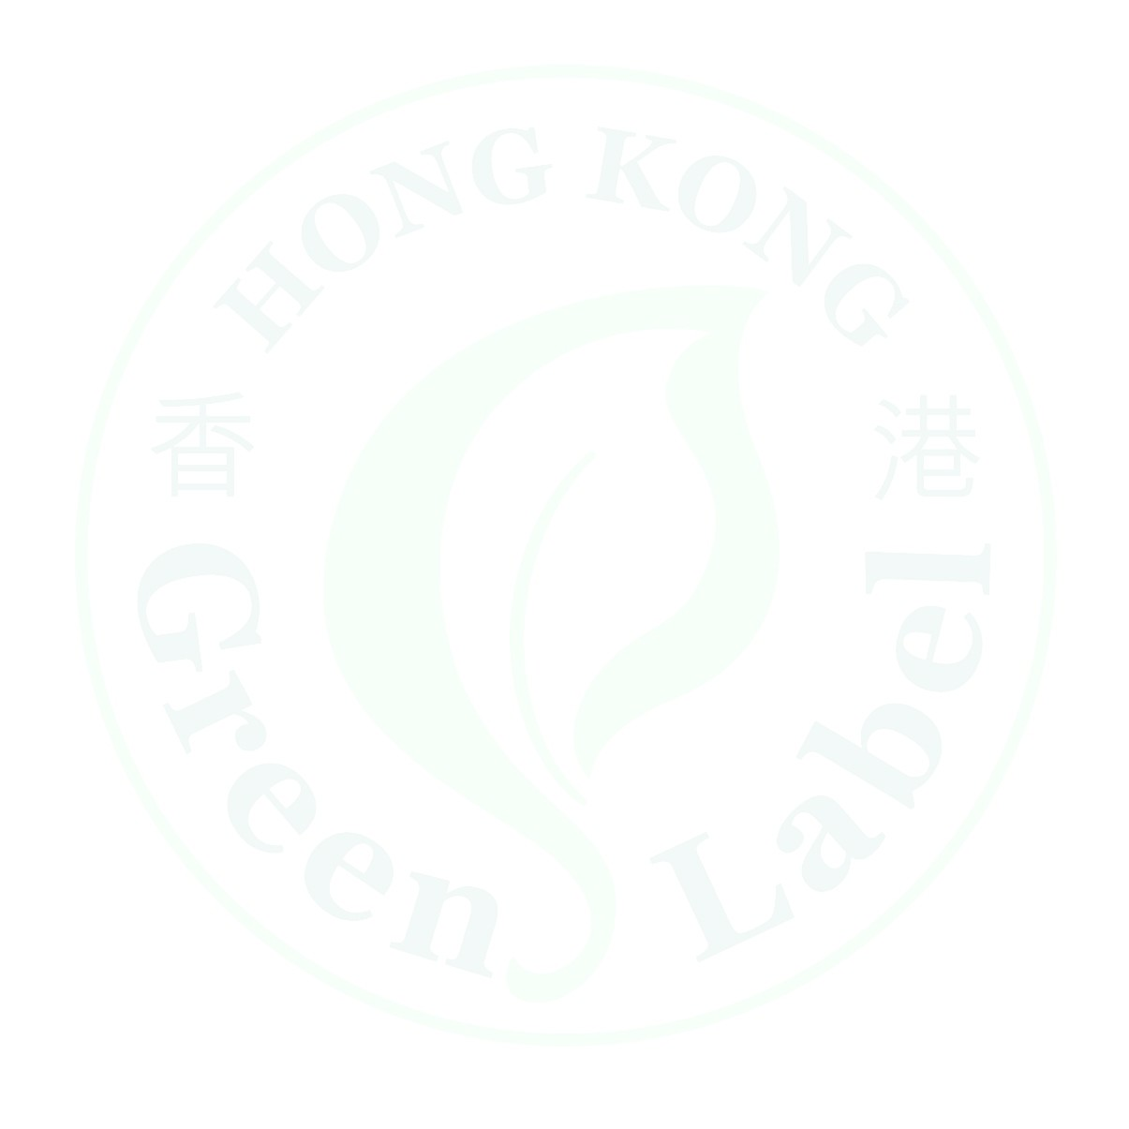
Cheque No支票號碼.
- HKD 8,000 (New Application Fee初次申請費)
- HKD 3,800 (Renewal Application Fee續牌申請費)
Notes備註: (1)  (2)  (3)  (4) | Cheques should be crossed and made payable to “Green Council”. Cash are not acceptable.  劃線支票抬頭請寫上「環保促進會」，現金恕不接受。  A tri-annual licence fee of HKD 6,000 per product and evaluation of HKD 2,000 per product will be payable upon approval of a new or renewal application.  申請或續牌申請一旦獲得批准，申請人需每個產品每三年繳交港幣6,000元牌照費及港幣2,000元評估費。  An administrative expense of HKD 4,000 will be applicable for unsuccessful application.  若申請不獲接納，環保促進會將收取港幣4,000元作行政費用。  The HKGLS application/renewal fee does not include bank charges and other extra fees (e.g. fees on remittance, postage, transportation, etc). The Applicant shall be responsible for settling the above expenses.  關於香港環保標籤計劃的基本申請費用／續牌費，不包括銀行收取各項的手續費及其他額外費用﹙例如匯款費、郵費、運輸費等等﹚，申請者須自行支付此等費用。

3. Declaration聲明
As the applicant of the Hong Kong Green Label Scheme, we hereby declare that by submitting this application, we the Applicant recognise that the Green Council (GC) operates the scheme of certifying businesses as having products that accord with certain environment qualities in accordance with Regulations, a copy of which we have been provided with this application form and which we have read and are familiar with (“Regulations”). We also agree that if our application for certification in respect of the specific Product noted above is successful, and in consideration of the GC agreeing to proceed with our application and auditing our Product, that we will comply with and be bound by the Regulations of the scheme which we consider to be fair and reasonable. We further undertake to pay all costs required in relation to our application and any future certification.  本人在此聲明，作為香港環保標籤計劃的申請人，本人在遞交申請表時，承認環保促進會負責辦理本計劃的認証工作，在遵照守則規定下，認証產品是否符合特定的環保準則。本人取得申請表，並已參閱及了解守則的內容。若有關上述產品的認証申請一旦被接納，而環保促進會同意處理該項申請及審核產品，本人同意遵照及受計劃守則所約束，並認為守則內容公平而合理。本人更承諾支付日後任何有關申請或認証所需的一切費用。 |  |  |  | For official use  內部專用
Name of Contact Person聯絡人姓名:

Position職位:

Signature簽署:____________________________________

Company Chop公司蓋章:____________________________

Date日期:

Purpose of Data Collection : All the information obtained from the
applicant organizations would be kept strictly confidential and used solely for the Scheme.
資料用途：所有申請人提供的資料將予保密，只會作申請本計劃之用。

The information provided in this application is to be used for the purposes of assessing your application for a green label. GC’s policies and practices in relation to personal data provided by applicants and the Personal Data (Privacy) Ordinance is available upon request at GC.
申請表提供的資料，只作審核環保標籤申請之用。對於環保促進會根據個人私隱條例，制定有關處理申請者個人資料的政策及指引，可向本會索閱。

(For official use only)內部專用

Entry reference no. by

Date of receipt

Information to be supplemented

Written acknowledgement yes/no

(Date )

